**Set of trendy watercolor abstract framed art**

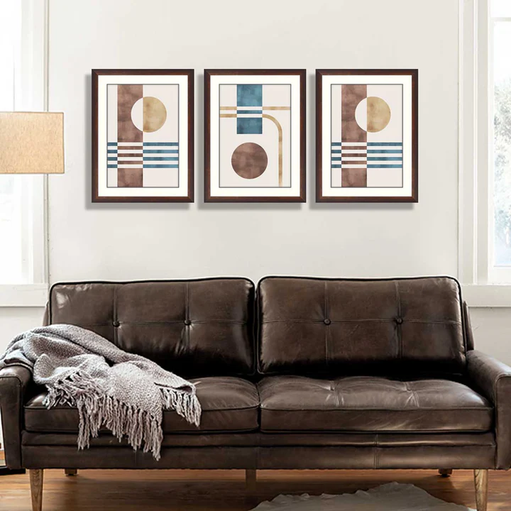This set of trendy watercolor abstract framed art adds a sophisticated and artistic flair to any interior. The three pieces feature soft, flowing layers of earthy orange, yellow, and deep blue tones, blending harmoniously in a serene abstract style. Delicate crane birds in flight are subtly integrated into the designs, enhancing their elegance and tranquillity. Encased in sleek black frames, the artwork is perfect for creating a modern focal point. Paired with a cozy seating area featuring vibrant striped and solid cushions, this setup radiates warmth and style, ideal for contemporary or minimalist spaces.